Section 1-1: Design
    - Definition of design
According to the Oxford Dictionary:
Design 1 n. sketch or plan etc. for future product; art of making these; scheme of lines or shapes forming a decoration; layout; established form of a product; mental plan; purpose; 2 v. make design for; be designer; intend.
For every day usage, design as a noun is the plan or convention for the development of an object or a system (as in architectural blueprints, engineering drawing, business process, circuit diagrams and sewing patterns).
One of the basic characteristics of human beings is that they make a wide range of tools and other artefacts to suit their own purpose. Design has been inherent in human beings, and people have therefore always designed things.
Engineering design is concerned with problem solving. It is concerned with the art of using science in achieving a useful end-product.
In traditionally-craft-based societies, design is not separated from making (i.e. No drawings or modelling is done before producing the actual object). Example a potter will make a pot by working directly with the clay. However, in modern industrial societies activities of design and making are usually quite separate. The design provides a description of the artefact before it is made. It specifies the object down to its most detailed dimensions, kind of surface finishes, material etc.

Section 2-1: Principles of Design
2-1.1 Design Principle
Successful designers usually follow some sort of methodical approach to problem-solving. These methods evolve over years of practice on a diversity of problems and a number of attempts have been made to systematise a pattern of events which might be classified as principles. These attempts have been successful to the extent that a method is an improvement on intuitive and adhoc arrangements. Nevertheless the' principles' should not be regarded as axiomatic for the very simple reason that judgment is needed in making decisions in problems governed by vastly different sets of variables for which there exist differing degrees of lack of information. They are not the purely scientific, axiomatic principles, such as the laws of statics or thermodynamics, which are already part of the engineering curriculum, but derive more from experience, practice or pragmatism. This is also referred to design process and it is generally characterised by design process models.
An awareness of fundamental design principles enable engineer to engage in the highest level of decision making to which they can then bring their professional skill and training.
2-1.2 Strategies to reach a design goal
strategies to reach a design goal
Strategies to reach a design goal can be classified within two categories:
- Solution-oriented, in which an initial solution is proposed, analyzed and then repeatedly modified as the design space and requirements are explored together. The model of this design process tends to describe the sequences of activities that typically occur in designing. It is known as the Descriptive models.
- Problem-oriented, in which the emphasis is placed upon abstraction and thorough analysis of the problem structure before generating a range of possible solutions. It model attempts to prescribe a better pattern of activities.
Prescriptive models are concerned with trying to persuade or encourage designers to adopt improved ways of working. They offer a more algorithmic, systematic procedure to follow and are often regarded as providing a particular design methodology. It is denoted as systematic engineering design, and it posses the following properties:
- The rules within this method should be in a position to deliver all the possible solutions to a technical problem ensuring that the best solution is not left out.
- The rules should enable the selection of the best solution out of a lot of possible solutions
However, the selection of the best solution may require the knowledge of all the solutions to a particular technical problem.
The prescriptive model below is based on a basic structure according to Pahl and Beitz:
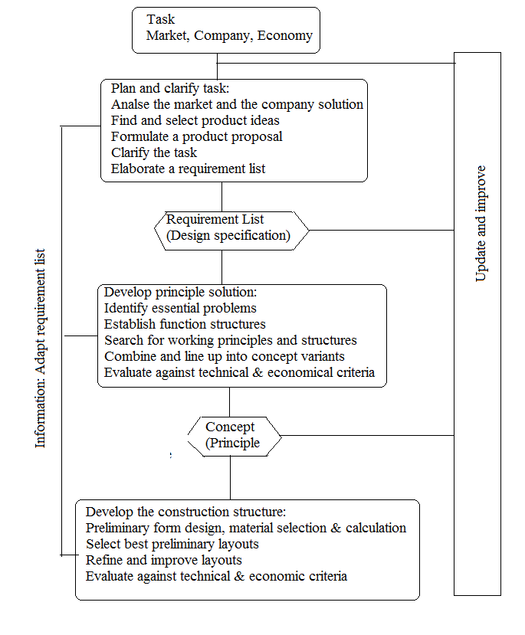
Source: According to Pahl / Beitz
Task/Problem
Task: Imaginable target (purpose, result) under given conditions
Problem: Task or assignment, to which the solution cannot be realized directly or reached by known means
Purpose of a Technical System:
The first and most important step with setting up a requirements list is the specification of the purpose of the product or technical system.
The purpose describes the intended use of a product solution-neutrally. The kind of product is related to its purpose:
Kind of product = f (purpose).
Example 1:
Product | Purpose
brake on a bike | reduce speed of bike
refrigerator | cool down, keep cool or increase self life of food
bucket | store matter
automobile | transport people or goods
photo copier | replicate data
lock on a door | protect against unwanted opening of door

Task Definition of Technical Systems
From the early definition of a task, it is said to consist of a purpose and conditions. Therefore, the task definition of a technical system involves determining:
- What purpose the system has to fulfill? Remember technical systems can only:
- Transfer or convert energy
- Transfer or convert material
- Transfer or convert signal/information
- What boundary conditions/restrictions have to be considered (Objectives)?
- Market requirements
- Laws, directives...
- In your own resort: production, transport...
- Society/politics
A comprehensive guide to arrive at boundary conditions is shown in the diagram below.
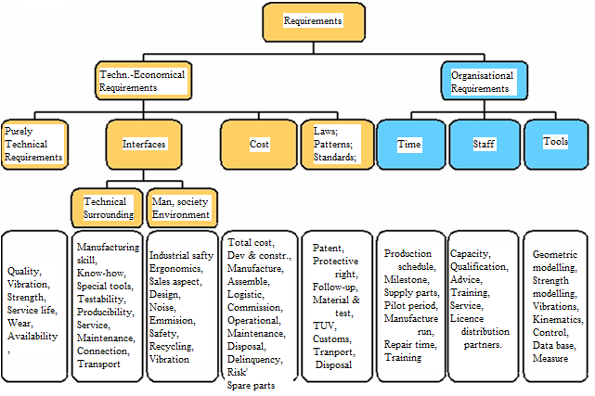
But a faster or simplified guide at arriving at various conditions is provided by the checklist or main-headings table below.
Checklist (Main headings)
Main headings | Examples
Geometry | Size, height, breath, length, diameter, space requirement, number, arrangement, connection, extension
Kinematics | Type of motion, direction of motion, velocity, acceleration
Forces | Direction of force, magnitude of force, frequency, weight, load, deformation, stiffness, elasticity, stability, resonance
Energy | Output, efficiency, loss, friction, ventilation, state, pressure, temperature, heating, cooling, supply, storage, capacity, conversion
Material | Physical and chemical properties of the initial and final product, auxiliary materials, prescribed materials (food regulations etc.)
Signals | Input and output form, display, control equipment
Safety | Direct safety principles, protective systems, operational, operator and environmental safety
Ergonomics | Man-machine relationship, type of operation, clearness of layout, lighting, aesthetics
Production | Factory limitations, maximum possible dimensions, preferred production methods, means of production, achievable quality and tolerance
Quality control | Possibilities of testing and measuring, application of special regulations and standards.
Assembly | Special regulations, installation, seating, foundations
Transport | Limitations due to lifting gear, clearance, means of transport (height and weight), nature and conditions of despatch.
Operation | Quietness, wear, special uses, marketing area, destination (for example sulphurous atmosphere, tropical conditions).
Maintenance | Service intervals (if any), inspection, exchange and repair, painting, cleaning
Recycling | Re-use, reprocessing, waste disposal, storage.
Costs | Maximum permissible manufacturing cost, cost of tooling, investment and depreciation.
Schedules | End date of development, project planning and control, delivery date.
According to Pahl / Beitz
These boundary conditions consist of a mixture of abstract and concrete conditions that the designer must satisfy. For example, the product must be safe and reliable is rather vague and the designer needs to expand and clarify such statements. Whereas the cost of the product must be between ¢400.00 and ¢500.00 specifies a limit and precise.
One way to begin to make a vague statement more specific is to specify what it means. For example for a working tool that it must be ‘safe’ might be expanded to:
- Low risk of injury to operator,
- Low risk of operator mistakes,
- Low risk of damage to work-piece or tool,
- Automatic cut-out on overload.
The last statement is a means to achieve safety, whereas the first three statements try explaining safety as regards to specific situations.

Setting Up a Requirement List
The information (purpose, conditions) gathered above when put down is called the requirement list or product specification. It has a specific format. The condition can be classified as either a demand or a wish. Demands must be met at all cost, while wishes will be met to a certain degree.
0
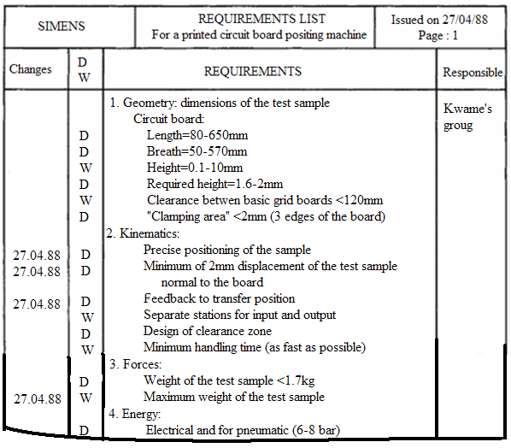
Conceptual Design
Functional Structure
The intended technical system will have to perform certain function(s). A task or function can be described via the input and output:
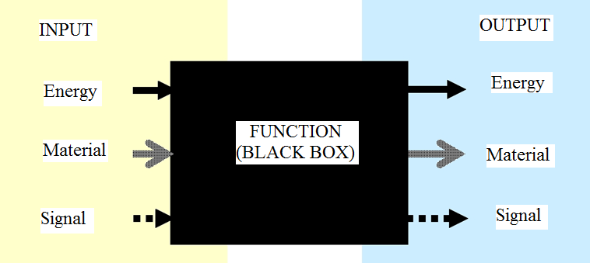
To obtain clear tasks, the purpose (overall function) is broken down into sub-functions. These sub-functions can be reduced to elementary functions that can be realised. For realization of the overall function the sub-functions (realisable functions) are linked via relations. The result is the function structure:
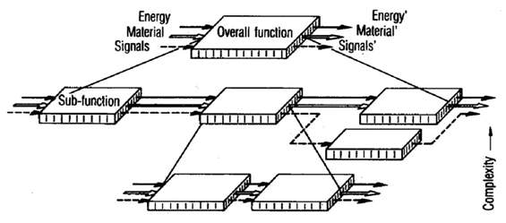
Methods of Developing Partial Solution
Solutions for the respective sub-function must found. These solutions are partial solutions, and there are several methods that can lead to developing these solutions.
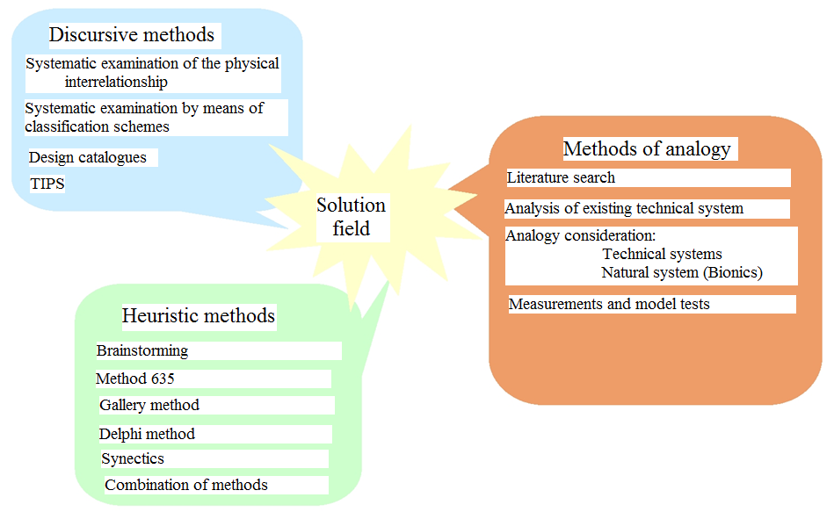
Source:
Example:

For certain sub-functions, more than one solution can be found. If these partial solutions are entered into a table with the format below the morphological–Matrix is obtained.
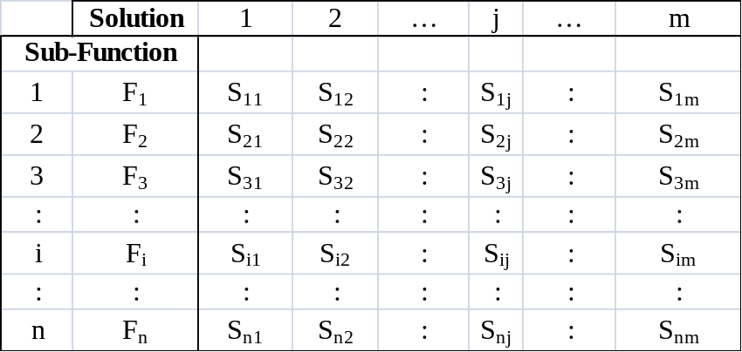
Setting Overall Solution (Concept)
Structurally connecting all partial solutions gives rise to the overall solution. This selection can be done by mapping in the morphological matrix. Each mapping gives rise to a concept.
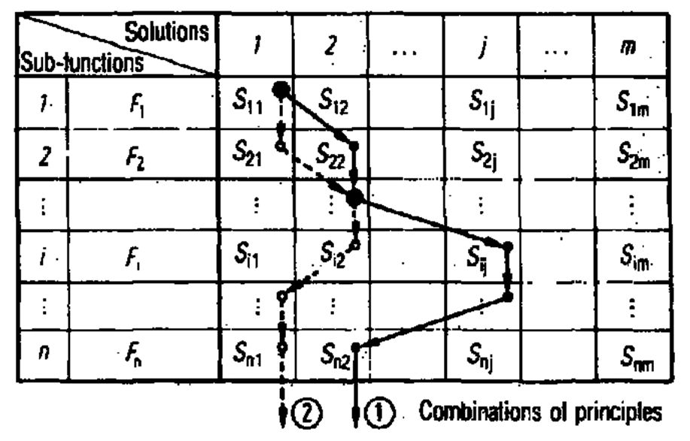
Evaluation / Selection
Evaluation is comparing found ideal solutions with found solutions among one another.
Evaluation criteria have to be defined for a limited amount of solution of any kind and field and any degree of definition, but equal information content.
Identify the evaluation criteria by taking a look at the requirement list and examine their importance to the overall value and eliminate non-important factors and consider the wishes and demands of the requirement list. Specify a numerical value for every criterion to each solution and their sums (overall values) are then compared as a ranking in order to find the best solution with the highest rating and the poorest solution with the lowest rating.
Embodiment
This is assigning shapes (form or feature) to a part in order that the part may perform its function properly.
Model Development & Testing
The first product is called a model. The model is subjected to experimental test and issues such as noise, vibration, wear etc. are evaluated.

